Question 1
Heat pumps and refrigerators are Identical, they both transfer heat energy from one location to another, however heat pumps are used to transfer heat energy from the exterior into a usually insulated space. Refrigerators do the opposite; they transfer energy from a generally well-insulated space to the exterior. Thus, to show these differences they have different formulas for efficiency.
Refrigerator
The work done by the refrigerator is given by $W_{cycle}=Q_{out}-Q_{in}$
The C.O.P. (Coefficient of Performance) of Refrigerator is $β=\frac{Q_{in}}{W_{cycle}} =\frac{Q_{in}}{Q_{out}-Q_{in} }$
We can estimate this is equal to$\frac{T_{C}}{T_{H}-T_{C}}$

Heat Pump
The work done by the heat pump is given by $W_{cycle}=Q_{out}-Q_{in}$
The C.O.P. (Coefficient of Performance) of heat pump is $γ =\frac{Q_{in}}{W_{cycle}} =\frac{Q_{in}}{Q_{out}-Q_{in}}$
We can estimate this is equal to$\frac{T_{H}}{T_{H}-T_{C}}$
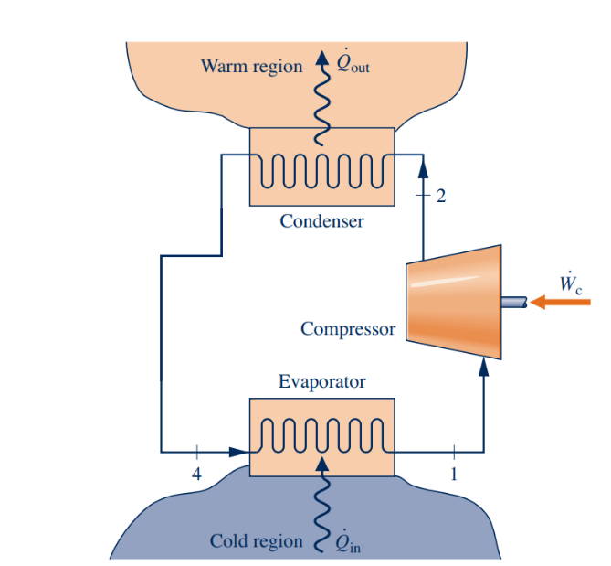

Question 2.
Heat pumps rely on heat energy in the outdoor air to keep the dwelling at comfortable temperatures, thus as the exterior’s temperature reduces, there is less available heat energy to utilize. Using the C.O.P. formula given for Heat pumps on page 1, we can visualize what happens as the temperature drops.
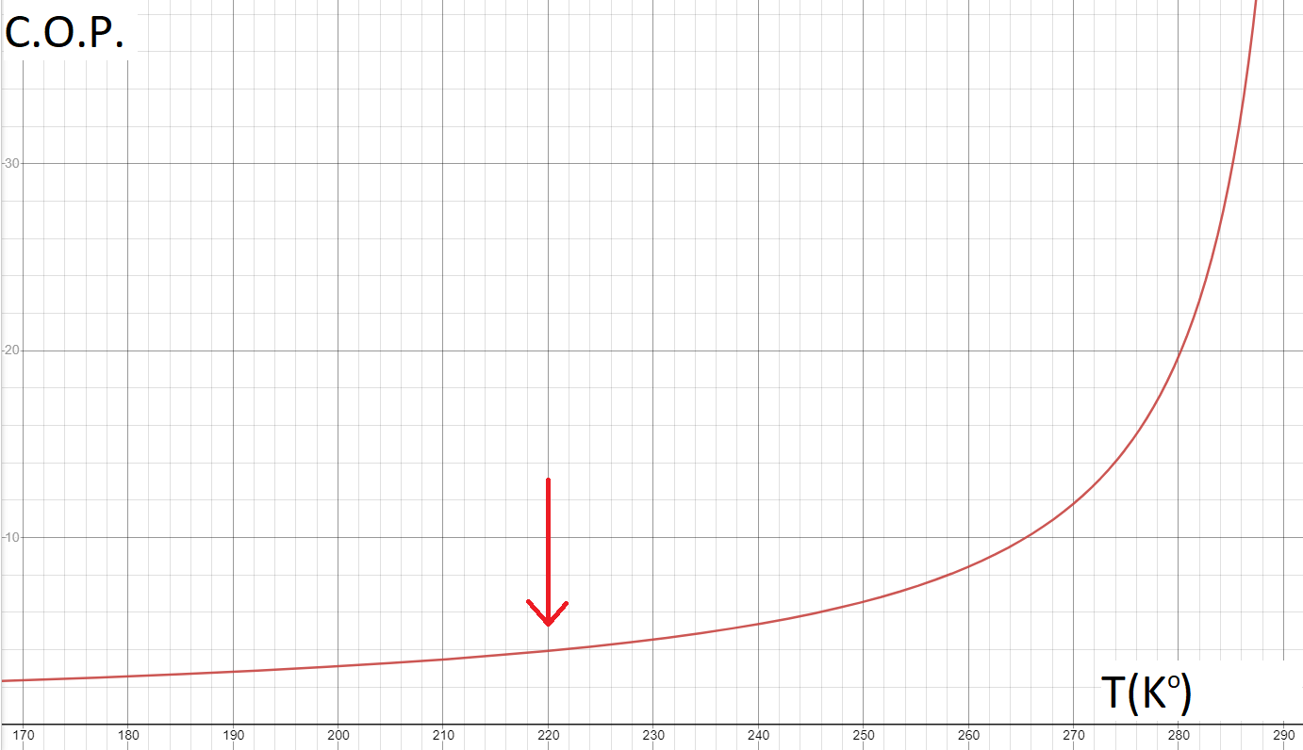
Assuming the interior temperature is 295 °K, the C.O.P. drops dramatically as exterior temperature decreases. Although the graph looks smooth, at the 220°K, the system will be almost nonfunctional due to the fact that the refrigerant, R-410a, becomes a liquid at this temperature. However, there are many other variables unaccounted for at play here. As the refrigerant becomes less efficient due to not being able to convert to a gas, the available heat energy is also dropping, and due to these two main factors, efficiency drops more dramatically than implied by the above graph. For these reasons, heat pump systems are generally not used in areas with extremely cold weather conditions. Once a heat pump’s C.O.P. drops below 1, more conventional heating systems will be as, or more efficient. For example, Electric resistive heating has C.O.P. of 1 regardless of the exterior conditions. Generally, heat pumps are rated for efficient operation within a certain temperature range, so a homeowner can determine whether to install a heat pump or not.

Problem 3
Air at 1600 K, 30 bar enters a turbine operating at steady state and expands adiabatically to the exit, where the temperature is 830 K. Assume ideal gas behavior for the air and ignore kinetic and potential energy effects. If the isentropic turbine efficiency is 90%, determine
(a) the pressure at the exit, in bar
$$\frac{T_{2}}{T_{1}}={\left(\frac{p_{2}}{p_{1}}\right)}^{\frac{k-1}{k}}→\frac{830}{1600}={\left(\frac{p_{2}}{30}\right)}^{\frac{1.4-1}{1.4}}→{\left(\frac{830}{1600}\right)}^{3.5}=\frac{p_{2}}{30}→p_{2}=3.01 bar$$
(b) the work developed, in kJ per kg of air flowing.
$$η_{t}=\frac{h_{1}-h_{2}}{h_{1}-h_{2s}}→0.9=\frac{1757.57-h_{2}}{1757.57-\frac{843.98+866.08}{2}}→h_{2}=945.284$$
$$\frac{\dot{W}}{\dot{m}}=h_{1}-h_{2}=1757.57-945.284=812.29\frac{kJ}{kg}$$

